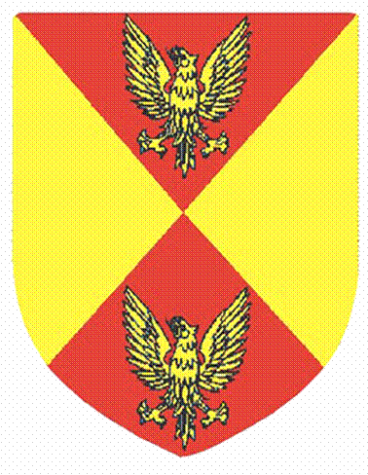
COPPULL PARISH COUNCIL

PLEASE NOTE

AS THIS IS AN ELECTION YEAR, THE ANNUAL GENERAL MEETING OF THE PARISH COUNCIL HAS BEEN PUT BACK ONE WEEK, AS FOLLOWS:

CHANGED FROM WEDNESDAY 8 MAY 2019
TO
WEDNESDAY 15 MAY 2019

COMMENCING AT 7.00 P.M.
IN THE MEETING ROOM

AT

SPRINGFIELD PARK LEISURE CENTRE
SPRINGFIELD ROAD NORTH
COPPULL PR7 5EG

