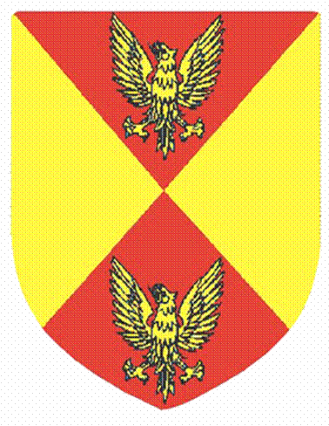

COPPULL PARISH COUNCIL 2020/2021

Due to the Covid-19 pandemic in 2020, the Parish Council has only held three statutory council meetings in this financial year - August 2020, November 2020 and February 2021. The Annual General Meeting was cancelled in May 2020, with members agreeing that the Chair and Vice-Chair at the time continue for a further year. The Annual Parish Meeting for residents was also cancelled due to Covid-19. There have been no Management & Finance Committee meetings held throughout the year, again keeping meetings to a minimum due to Covid-19.

PLEASE NOTE: If a member fails throughout six consecutive months to attend ANY meetings of the Council OR of its committees or sub-committees of which he/she is a member, he/she ceases automatically to be a member of the Council, unless either he/she has a “statutory excuse” or his/her failure is due to a reason approved by the Council, or if he/she attended as a representative of the Council at a meeting of any body (such as a County Association of Local Councils).

Councillors’ attendances for the above meetings are as follows:

Name | PC  Aug 20  Hybrid | PC  Nov 20 Zoom | PC  Feb 21  Zoom | PC  APR 21  Zoom | Reason for absence –  approved by the Parish  Council
Councillor Michael Atherton (Chair) | Yes | Yes | Yes | Yes
Councillor Marjorie Parkinson  (Vice-Chair) | Yes | Yes | Yes | Yes
Councillor Nora Ball | Yes  Zoom | Yes | Yes | No | Illness
Councillor Pauline Cobham | Yes | Yes | Yes | Yes
Councillor Neil Coggins | Yes | Yes | Yes | No | Another commitment
Councillor Jan Colecliffe | Yes | No | No | Yes | Working (key worker)
Councillor Matthew Crook | No | Yes | Yes | Yes | Holiday
Councillor Paul Eastham | No | No | No | Yes | Another commitment, Operation, Illness
Councillor Steve Holgate | Yes  Zoom | Yes | Yes | Yes
Councillor Elaine Jones | Yes | Yes | Yes | No | Another commitment
Councillor Sheila Makin | Yes | Yes | Yes | Yes
Councillor Lynne Moores | No | Yes | No | Yes | Illness
Councillor Maggie Peel-Impey | Yes | Yes | No | Yes | Illness
Councillor Paul Taylor | Yes | No | Yes | No | Working
Councillor Ashley Whittaker | No | Yes | Yes | Yes | Another commitment

